Admin Dashboard Page:
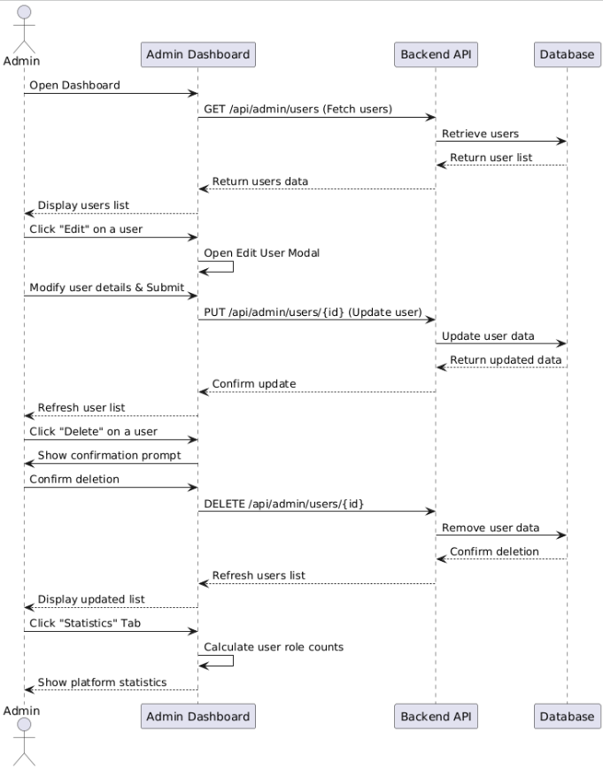

Database:
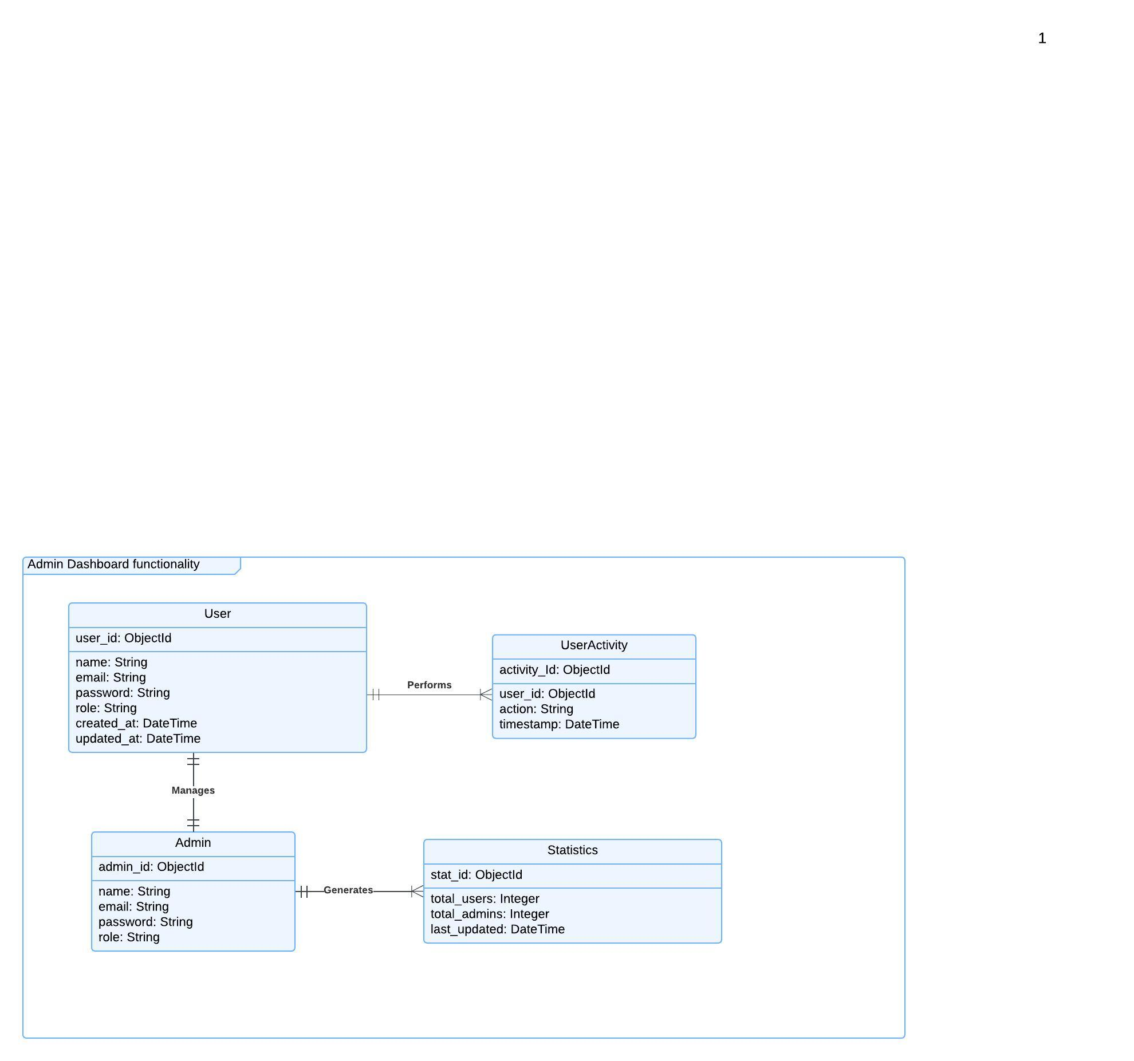

Functional Requirements (FRs)
User Management
- FR1: The system shall allow admins to fetch a list of all registered users.
- FR2: The system shall allow admins to update user details (name, email, role).
- FR3: The system shall allow admins to delete users after confirmation.
- FR4: The system shall maintain activity logs for user modifications.
- FR5: The system shall refresh the user list after an update or deletion.
Statistics & Reporting
- FR6: The system shall display user role statistics (e.g., count of admins, users).
- FR7: The system shall allow admins to fetch platform statistics on demand.
- FR8: The system shall automatically update statistics after user modifications.

Non-Functional Requirements (NFRs)
Performance & Security
- NFR1: The system should retrieve user lists in under 2 seconds.
- NFR2: The system should support simultaneous admin operations without performance degradation.
- NFR3: User data should be stored securely using password encryption.
- NFR4: The system should implement role-based access control (RBAC) for admins.

